INDIAN SCHOOL AL WADI AL KABIR
CLASS: VII | DEPARTMENT: SCIENCE | DATE: 22-05-2022
MARKS: 30 | PRE - MID TERM  ANSWER KEY | DURATION: 1 HOUR
PREPARED BY:
VIKRANT V. PURANDARE

ANSWER KEY
1 | 2 | 3 | 4 | 5 | 6
[d] Guard cell [1] | [b] Saprotrophic nutrition [1] | [c] Not flow from copper ball to water or from water to copper ball. [1] | [iii] A is true but R is false. [1] | [i] Both A and R are true and R is the correct explanation of assertion. [1] | [ii] Both A and R are true but R is not the correct explanation of assertion. [1]
7) a) Manures and fertilisers contain plant nutrients such as nitrogen, potassium and phosphorus needed by plants for healthy growth. These nutrients need to be added time to time to enrich the soil. [1]
b) Rhizobium bacteria, living in the root nodules of leguminous plants, takes the atmospheric nitrogen and converts it into a soluble form which can be absorbed by the plants. [1]
c) The plants cannot use nitrogen in the manner they use carbon dioxide. They need nitrogen in soluble form. [1]
8) a) Mercury is very commonly used in thermometers because – (Any 2 – ½ + ½)
i) It is the only metal which is found in liquid state.
ii) It does not stick to the walls of the glass.
iii) It’s boiling point is very high and has low freezing point.
iv) It is shiny which makes it easily visible through the glass.
v) It expands equally for every degree of rise in temperature.
b) Jerks are given to a clinical thermometer before using it to settle down the mercury level below 35°C so that the measurement taken be accurate. [1]
c) The temperature of human body does not go below 35 ˚C or above 42 ˚C. [1]
9) a) Conduction is the process of transfer of heat from the hotter end to the colder end without any actual movement of the molecules of the material. [1]
b) Plastic is a bad conductor of heat due to which the heat from the cooker does not flow to its handle and we can hold it easily. [1]
c) Heat can be conducted from one body to another only when they are – i) in solid state, ii) in contact with each other, ii) at different temperatures. (Any 2 – ½ + ½)
10) a) Algae contains chlorophyll and provide food to the fungus. While the fungus provides water, minerals and shelter to the algae. [1]
b) Insectivorous plants have green leaves and can perform photosynthesis to prepare their own food, but they grow in nitrogen deficient soil. So, they feed on insects to obtain nitrogen compounds needed for their growth. [1]
11) a) Kink prevents immediate backflow of mercury from the tube to the bulb, thus it allows us to read the temperature conveniently. [1]
b) The heater warms the air near the floor. When the warm air rises upwards, the cool air sinks to the floor to fill the empty space. This results in effective heating of the room. [1]
12) a) White colour reflects most of the sun’s heat rays and keeps the house cool. [1]
b) The two thin blankets joined together will have a layer of air trapped in-between them. Air doesn’t allow our body heat to escape to the cold surroundings and hence keep us warm. [1]
13) [2 + 1]
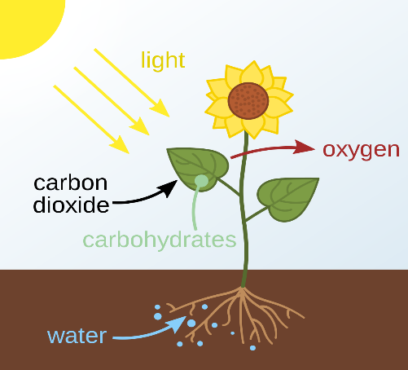
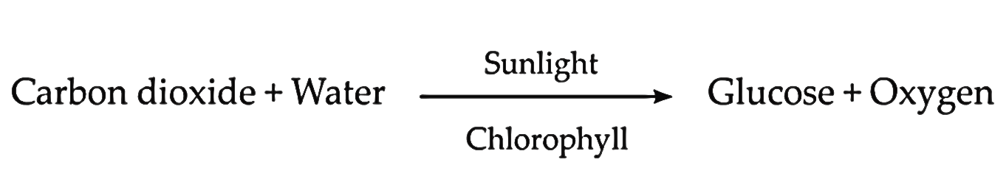
14) a) Cuscuta does not have chlorophyll. It takes readymade food from the plant on which it is climbing. This deprives its host of valuable nutrients. [1]
b) Stomata are the numerous small openings present on the lower surface of a leaf. Each of these pores is surrounded by a pair of guard cells. The stomata help in the exchange of gases, carbon dioxide goes in and oxygen is released out. [1]
c) The saprophytes secrete digestive juices on the decaying and dead matter. These juices convert the matter into a solution. The saprophytes then absorb the nutrients from the solution. [1]
15) a) SEA BREEZE - During the day, the land heats up much faster than sea water. So, air above the land becomes hotter and rises up. The cool air above the sea surface moves towards land to fill the space. This flow of air from sea towards the land is called sea breeze.
LAND BREEZE – At night, the land cools much faster than the sea water. So, the air above the land surface is cooler than the air over the sea. The warm air above the sea surface rises up. The cool air from the land moves towards the sea. This flow of air from land towards the sea is called land breeze. [1+1]
b) Precautions to be taken while using a laboratory thermometer – (Any 2 – ½ + ½)
i) Thermometer should be washed before and after use, preferably with an antiseptic solution.
ii) It should be kept upright, not tilted.
iii) Bulb should be dipped in the substance in the vessel.
iv) The bulb should not touch the sides or base of the container

